**Figures**

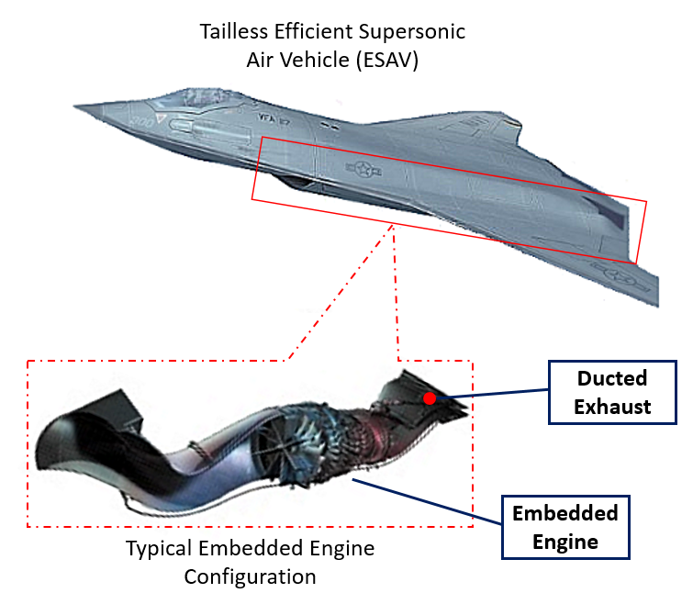

**Figure 1**: Tailless embedded engine configuration for a typical ESAV configuration. Expanded view shows the embedded engine configuration in more detail.

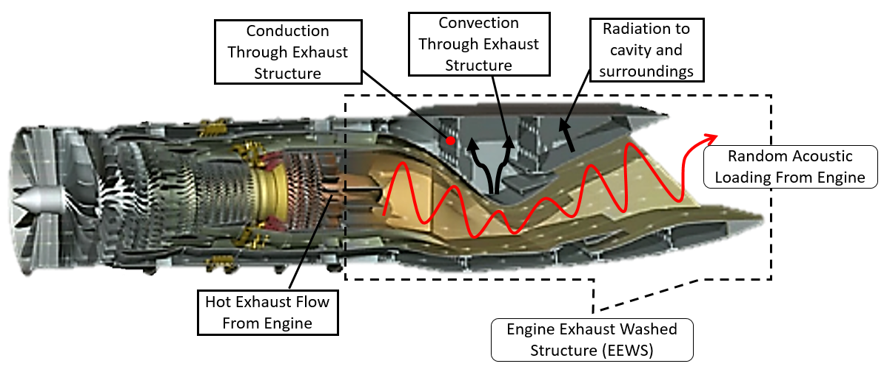

**Figure 2**: Acoustic and thermal loading environments often present in embedded engine configuration, which acts on the exhaust washed structure (EEWS)

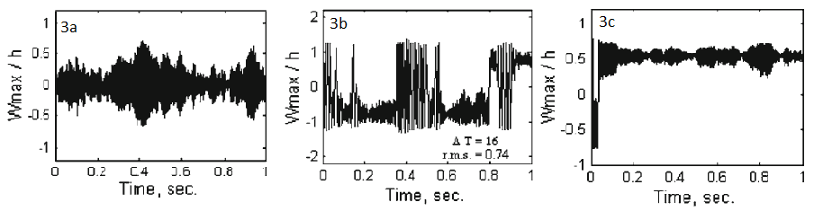

**Figure 3**: Dynamic response of aluminum panels subjected to thermal loading. 3a) non-buckled panel subject to acoustic loading. 3b) Post-buckled panel showing snap-though. 3c) Post-buckled panel vibrating about a buckled position.

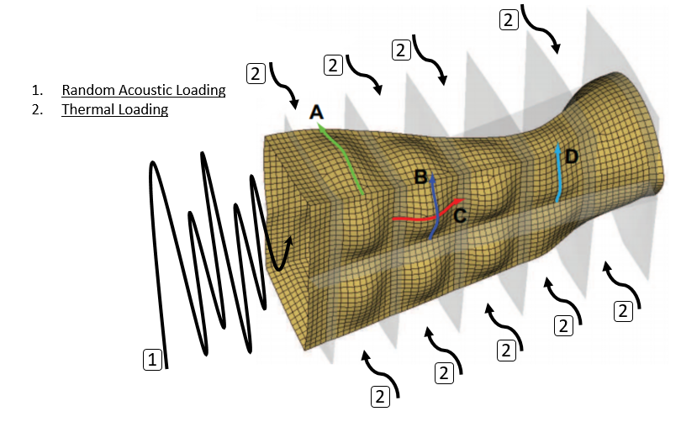

**Figure 4**: Deformation of the EEWS structure due to thermal expansion. Superimposed random acoustic loads with excite the thermally expanded structure, which drive a dynamics response at numerous excitation frequencies.

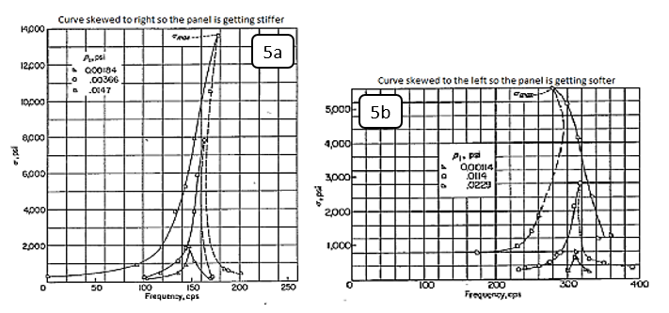

**Figure 5**: Asymmetric frequency response cures due to increased sound pressure levels. Figure on the left (5a) shows a response with increasing stiffness. Figure on the right shows a response with decreasing stiffness (5b)

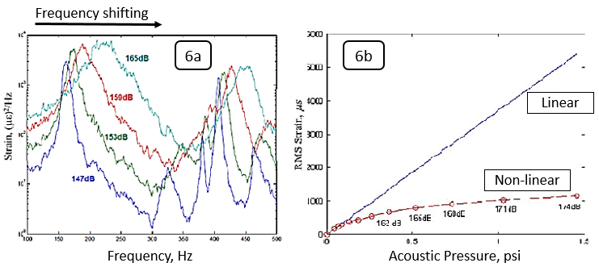

**Figure 6**: Frequency response function peak shifts and broadening due to nonlinear effects. Figure 6a shows non-linear effects on the frequency response. Figure 6b shows non-linear effects on strain estimations.